Student Worksheet

Snow White and the 8th Factor – Though hemophilia is rare, it is serious, so any research that points to a better understanding of possible treatments is valuable. Dr. Sanjeev Gupta and Dr. Antonia Follenzi and their colleagues have discovered where in the liver blood clotting Factor VIII is created.

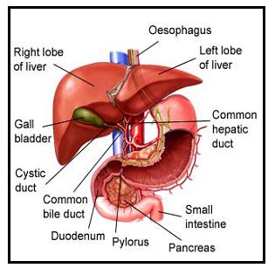
September – 2008
Have you ever heard of the condition called hemophilia? Do you know anyone with it? If so, you will know that blood clotting is crucial to people with hemophilia. The researchers highlighted this month are making progress in understanding the liver’s role in hemophilia and in finding ways to improve clotting.

To get the whole story, go to www.WhatAYear.org and click on the 09.08 icon.
- What exactly is a blood clot? Why does blood clot?
- Clotting is a very complex process. This month we are particularly interested in Factor VIII. A deficiency of Factor VIII leads to Hemophilia A. Describe hemophilia more fully.
- How common is hemophilia?
- Explain why only males can experience the consequences of Hemophilia A.
- If a person has hemophilia and receives a liver transplant, what change might occur?
- List three of the functions of the liver.
- Dr. Gupta, Dr. Follenzi and their colleagues originally sought the “factory” for Factor VIII in the hepatocytes. What happened?
- What was their next target of investigation?
- In further investigations with mice, what did the researchers discover?
- Dr. Gupta is optimistic about liver cell therapy. Why?
Liver image is from: http://www.best-vitamin-supplements-guide.com/symptoms-liver-disease-health.html

Here are some further topics to think about and research.
- A few famous people have had hemophilia. Research some of them and learn how the condition affected their lives.
- Hemophilia A is sex-linked. Are you aware of any other diseases or conditions that are sex-linked? What does it mean to be a carrier of a genetic condition, but not have that condition yourself?
- What is the ratio of people in the US with hemophilia? Do you know anyone with the condition? Is that ratio the same around the world, or are there locales/populations with different (higher? lower?) rates?
- Where does the word hemophilia come from and what is its root meaning?
- Dr. Gupta mentions liver cell therapy as a possible future cure for hemophilia. Are there any diseases that are already being cured by liver cell therapy? What are the current treatments for people with hemophilia?

