Student Worksheet

An Unseen Threat – Why shouldn’t pregnant women clean cat litter boxes? How can nearly 25% of Americans over age 12 be infected by a parasite and not know it? To learn more about Toxoplasma gondii and the work of Dr. Rima McLeod and her colleagues in fighting toxoplasmosis, check out this month’s What A Year! installment.

October – 2008
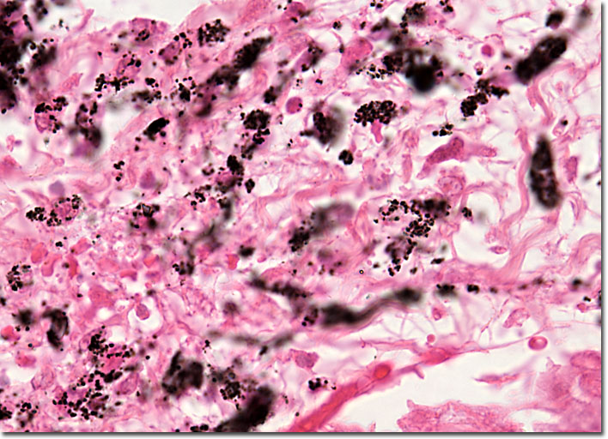
The parasite Toxoplasma gondii is ubiquitous. Yet few of us know about it or the harm it can cause. But the threat is truly there, complicated by the ability of some organisms to become resistant to drugs over time, so that the anti-parasite medicine that worked a few years ago may no longer work.

To get the whole story, go to www.WhatAYear.org and click on the 10.08 icon.

Note: Image from Human Pathology Digital Image Gallery at http://www.microscopyu.com/galleries/pathology/toxoplasmosislarge3.html
- The majority of otherwise healthy people infected with T. gondii are asymptomatic. What does that mean? And when they do show symptoms, they are often mistaken for what other illness?
- Who is especially at risk from toxoplasmosis?
- The parasite T. gondii can be transmitted three different ways. What are they?
- Why shouldn’t pregnant women clean out cat litter boxes?
- If a susceptible person does become infected, what are the symptoms of toxoplasmosis?
- If a child becomes infected within the womb and survives, what are some of the problems he or she may develop?
- How common is it in the US for a child to be born with toxoplasmosis?
- What is the connection between malaria and toxoplasmosis?
- There are several anti-malarial drugs, but their effectiveness becoming more limited. Why?
- Nevertheless, anti-malarials may be valuable in treating toxoplasmosis. In particular, Dr. McLeod and her colleagues are investigating a drug called JPC-2067B. What is so special about it?
- What is an in vitro test, and what did the in vitro tests of JPC-2067B show?
- Next there were in vivo tests. What did the in vivo test show?
- What is likely to happen next in testing JPC-2067B?

Here are some further topics to think about and research.

- Only 2 states test for toxoplasmosis in newborns (MA and NH). What are the conditions for which states are most likely to test? Why are those conditions included?
- Do you know anyone who has survived malaria? Ask what the disease feels like and what treatments the person got. Also ask if there are any long-term effects.
- What is the etymology of the word parasite?
- The T. gondii infection rate in the US is about 25% for adults, but much higher (~ 95%) in some parts of the word. Where are infection rates that high and what are the public health and economic consequences?

