Student Worksheet

Light Up Your Brain. How would you identify an individual neuron among the millions in the brain? What is a good way to watch neuronal development and change as the brain goes from infancy to adolescence to adulthood and old age? That is the challenge to Jeff Lichtman and his team of very ingenious researchers at Harvard.

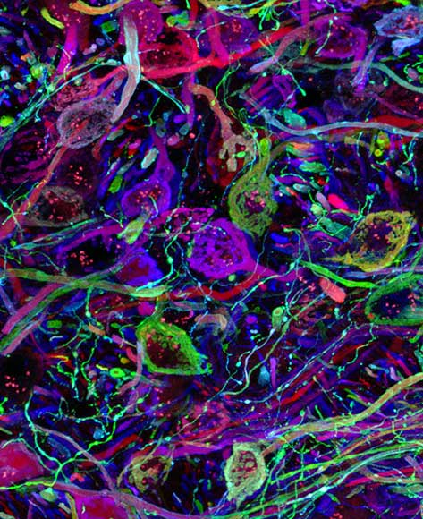
November – 2008
We all know that the brain is amazingly complex and that untangling its complexity is central to understanding both normal and abnormal brain development. But how do you look at a brain and identify its millions of components in a systematic way? Color coding is the approach used by Dr. Lichtman and his colleagues at Harvard University.
To get the whole story, go to www.WhatAYear.org and click on the 11.08 icon.
This picture: Neurons in the auditory portion of the brain stem. Images in the November What A Year! story are courtesy of Livet, Weissman, Draft, Sanes and Lichtman.
- Explain the distinct functions of what the writer calls the “wires,” the axons and dendrites in neurons.
- We are told that some of the brain’s wires are less then 200 nanometers apart and then we learn that 200 nanometers is approximately equal to 1/100 the width of a human hair. If that is the case, how many human hairs could you set side by side on a line 1 meter long?
- Approximately how many different colors can the Lichtman lab employ in its Brainbow?
- Your computer or television screen starts with tiny dots of just three colors. What are they?
- Most animal and human brains don’t naturally glow in a variety of colors. But there are some animals whose bodies give off chemically created light. What is the general term to describe these organisms?
- Define the word transgenic.
- What exactly did the Lichtman Lab team do to get different colors into neurons, axons and dendrites?
- We do get hauntingly beautiful pictures from the Brainbow mice. But the research goal is different: what does coloring the brain’s structures allow researchers to do now that they couldn’t do before?
- What do they plan to do with the mice?
- What future developments in “Brainbow” technology would they like to develop?

Here are some further topics to think about and research.

- Over the last 2 years, What A Year! has reported on several diseases that are caused by problems with the brain. Look through the Archive and find one or two and then try to determine if the Brainbow technique would be useful in research on that type of disease.
- The chemistry of bioluminescence is interesting. Learn how fireflies, corals and jellyfish glow, and what chemical reaction specifically produces each element of the spectrum of observed bioluminescent colors.
- The writer tells us this about brain development: if you don’t learn a language before a certain age, you will never learn it natively because of brain development. What is that age? Do you think that it is hopeless to start learning another language in high school?

