Student Worksheet

A Series of Rather Fortunate Events. Sometimes years or even decades elapse between a new medical theory and its broad acceptance. And more years may pass before a new drug or therapy arises from the theory’s being put into practice. Lodamin is a potential anti-cancer drug with a 30-year history.

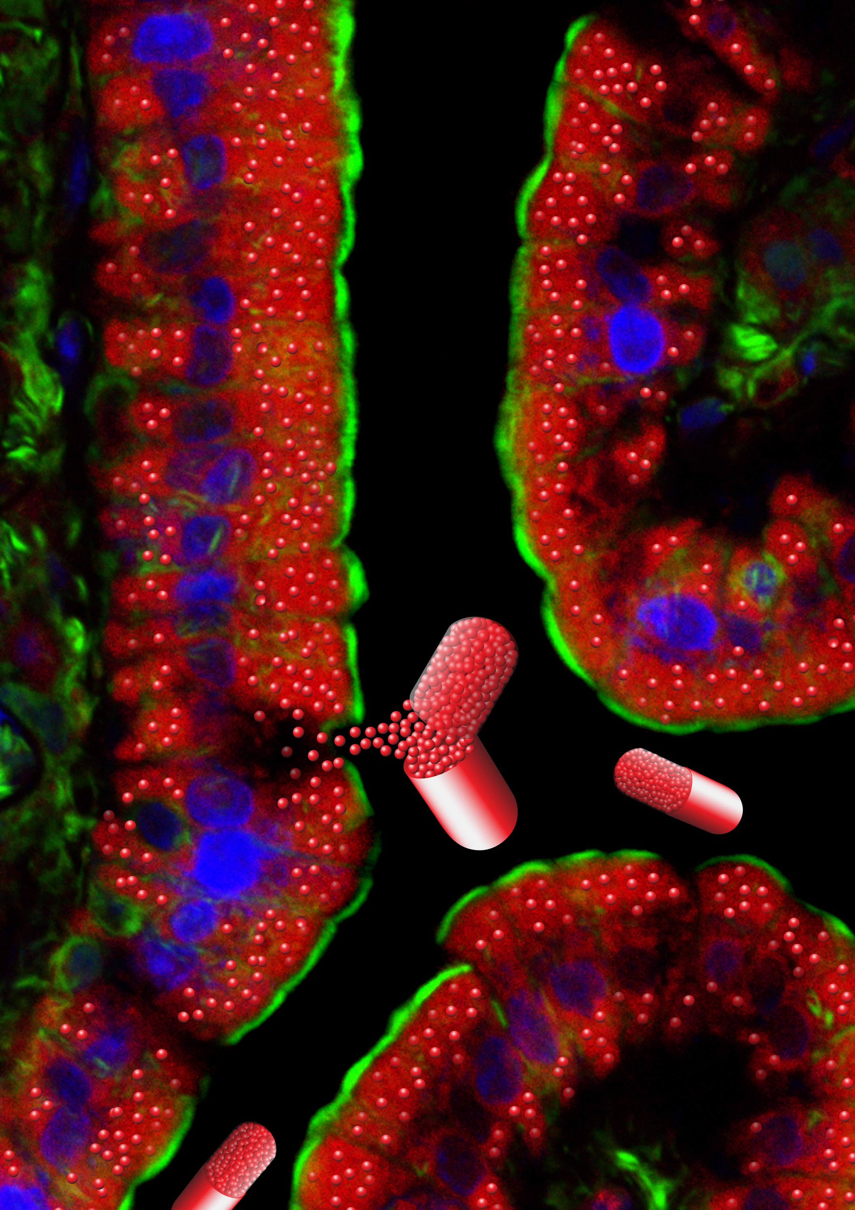
December – 2008
Dr. Judah Folkman’s theory that tumors create their own blood vessels is at the heart of research now happening in the laboratory of Dr. Ofra Benny at The Children’s Hospital – Boston. Many things had to happen between Dr. Folkman’s initial statement of his theory and the development of a potentially valuable anti-cancer drug called Lodamin.
To get the whole story, go to www.WhatAYear.org and click on the 12.08 icon.
This picture: Illustration of an oral drug in the form of nanoparticles being absorbed in the intestine. Photo courtesy of Dr. Ofra Benny.

- The story looks at cancer as a condition rather than a specific disease. What is that condition?
- Explain the difference between a benign tumor and a malignant tumor.
- What was Dr. Folkmans’s theory?
- What unexpected event led Dr. Ingber to a possible breakthrough in cancer treatment?
- In particular, how did Dr. Ingber and Dr. Folkman test the fungus Dr. Ingber had found?
- Their drug, called TNP-470, was effective in hindering tumor growth in patients in the 1992 clinical trial, but the drug trials were stopped because of bad side effects. What were those side effects?
- Why is it usually difficult to get a cancer drug to work in the form of a pill that that patient takes by mouth?
- The author uses an analogy to give us a sense of how big a nanometer is. What was that analogy? Also, how big is a meter?
- What is Dr. Benny’s specialty, and how did that come into play in developing Lodamin?
- Define the terms hydrophilic and hydrophobic
- Lodamin was first tested in vitro in capillary cell cultures. Then she and her colleagues moved on to test it against three cancers in mice. What cancers were they, and what were the results?
- What were the results of the neurotoxicity tests?
Here are some further topics to think about and research.

- At the end of November 2009, a change in the rate at which people in the US get cancer was reported. What was the news? How were men and women different? What kinds of cancer were most affected? What was most responsible for this change - lifestyle effects (smoking, eating, exercise, e.g.), environmental effects (air pollution, water, industrial chemicals) or medications and medical care (cancer drugs, e.g.)?
- What is a vaccine? Are there any anti-cancer vaccines being developed?
- Cancer is a general term and does not describe a single disease, but many. Cancers are often identified by their initial location: e.g., colon cancer, breast cancer, lung cancer. Why are some cancers more treatable/curable than others?

